GIT commands

**git config:**

**Usage: git config -–global user.name “[name]”**

**Usage: git config -–global user.email “[email address]”**

This command sets the author name and email address respectively to be used with your commits.

**Output:**

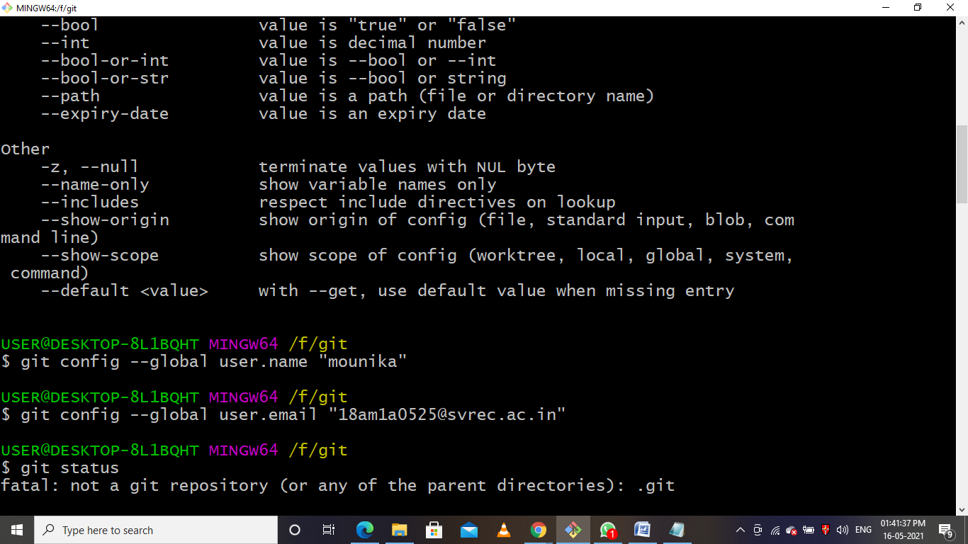

### ****git init****

**Usage: git init [repository name]**

This command is used to start a new repository.

**Output:**

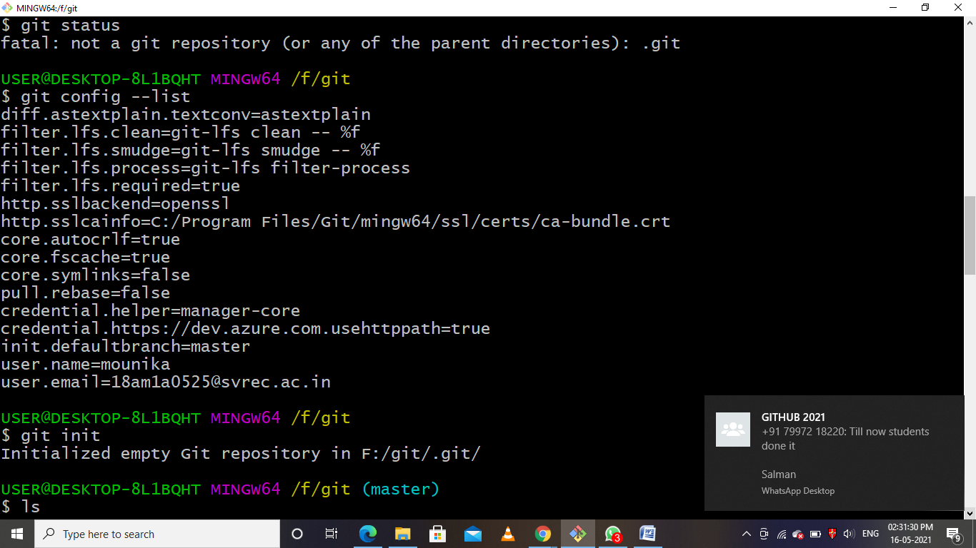

### ****git add:****

**Usage: git add [file]**

This command adds a file to the staging area.

**Output:**

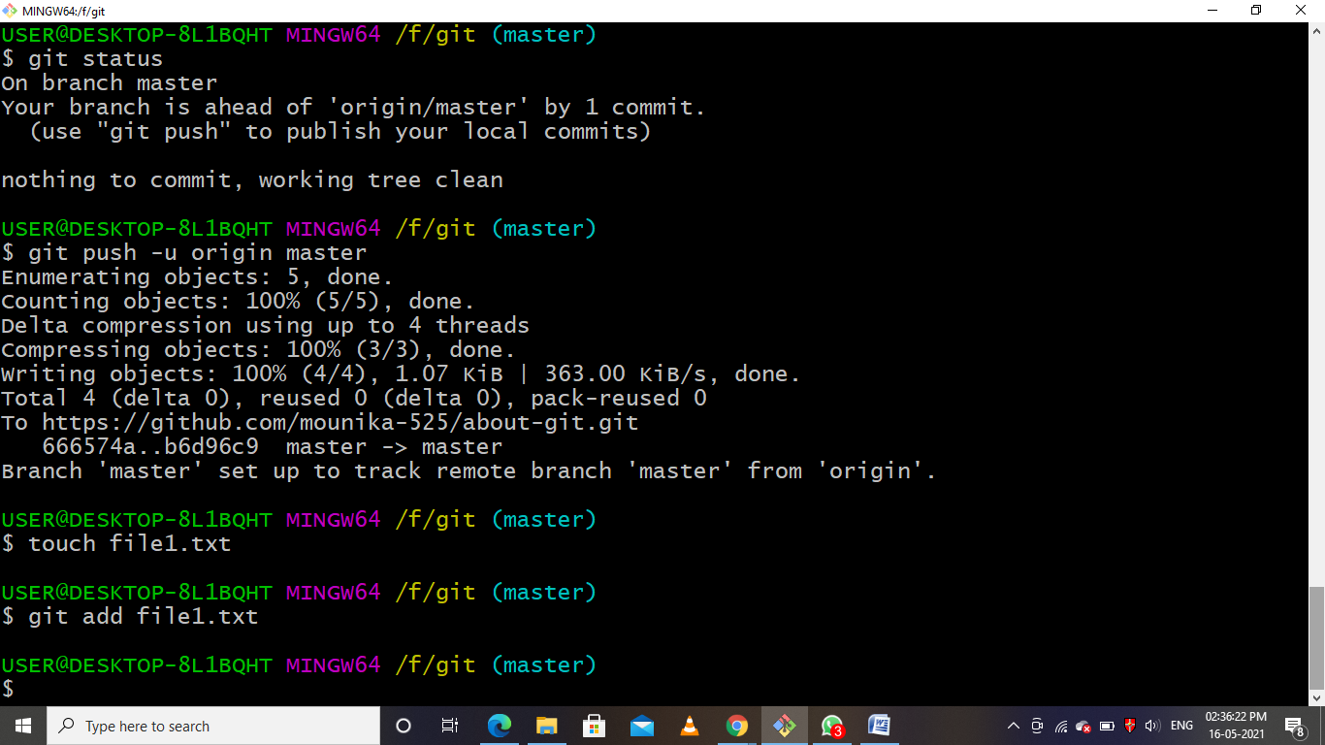

**Usage: git add .**

This command adds one or more to the staging area.

**Output:**

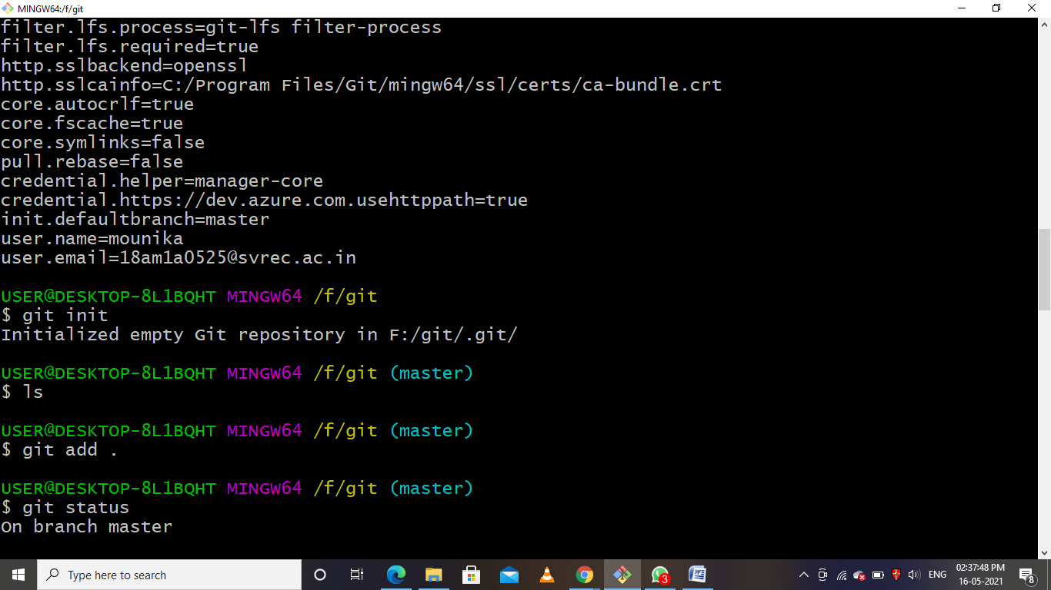

### ****git commit:****

**Usage: git commit -m “[ Type in the commit message]”**

This command records or snapshots the file permanently in the version history.

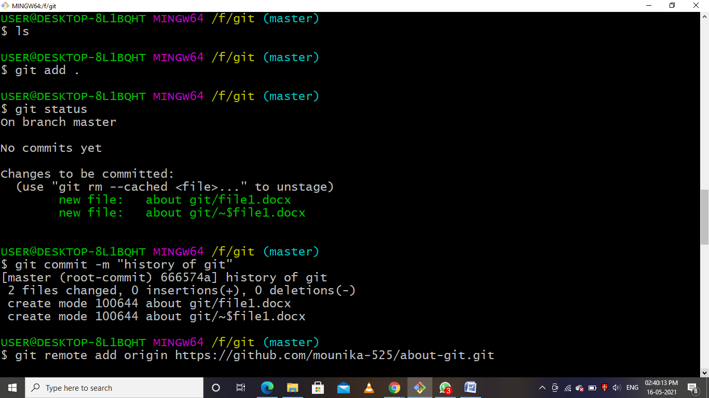

### ****git status:****

**Usage: git status**

This command lists all the files that have to be committed.

Output:

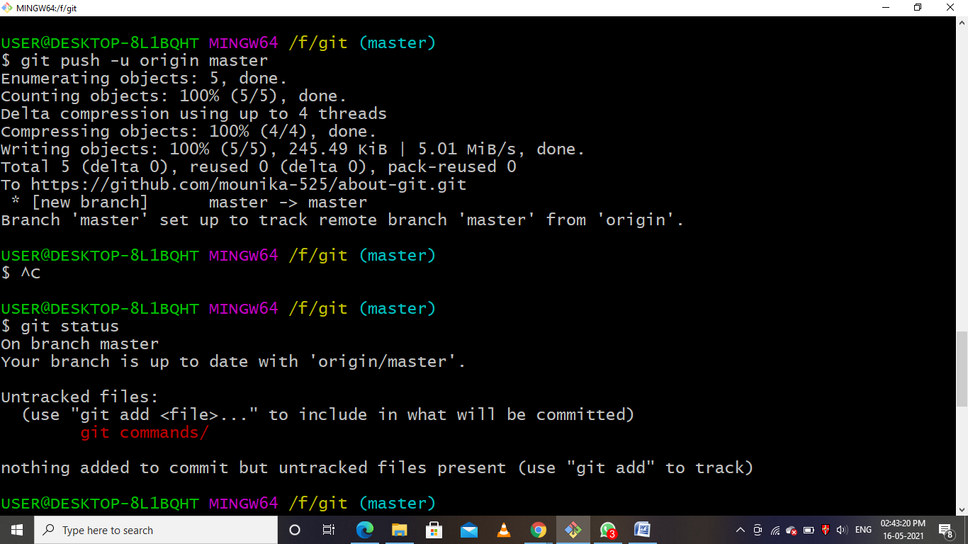

Git remote:

**Usage: git remote origin (url)**

This command list is used to connect with github repository.(it works through network.)

Output:

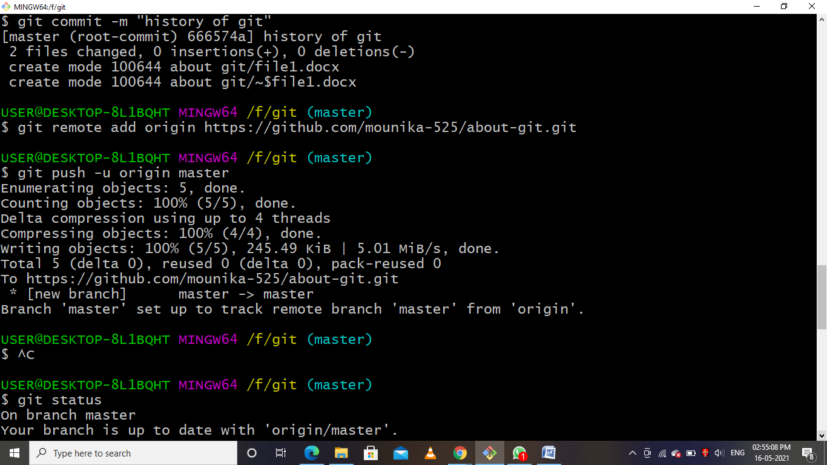

Git push:

**Usage: git push –u origin master**

This command list is used to add files from local repository to **server** repository.

Output:

